Enterprise (Contextual) Data Modeling - Diagram Report

**Alden**

Project Name: LawnCare Database Project

Description: To construct a database and application for interacting with it to serve the needs of a small lawn care company.

Index:

Enterprise Model: page 2

Entity: Owner: page 3

Entity: Property: page 3

Entity: Service: page 3

Entity: Workman: page 4

Entity: Equipment: page 4

Enterprise Model:

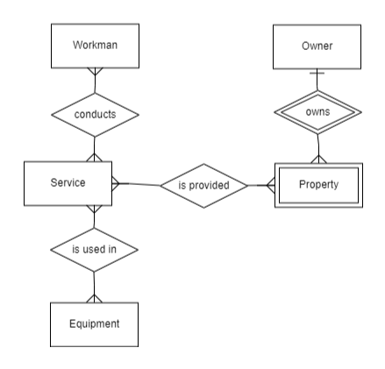

Entities:

Entity Name: Owner

Description: Stores an owners name and billing address as well as contact information.

Comments:

Purpose: An Owner registers properties with the company.

Relationship Name: owns

Description: An Owner owns many properties

Entity Name: Property

Description: Will store a property’s description and address.

Comments:

Purpose: Properties are what the company provides services for.

Entity Name: Service

Description: Will be one of many types of service provided to be performed on a property. Will contain a description and cost of the service.

Comments:

Purpose: A Service is what the company provides for customers to be performed on their properties.

Relationship Name: is provided

Description: A Service is provided to properties.

Entity Name: Workman

Description: Stores employee information such as name and contact info, as well as hire date and payrate.

Comments:

Purpose: Employees will carry out the services the company provides.

Relationship Name: conducts

Description: An Employee conducts the services that are scheduled for a property

Entity Name: Equipment

Description: Stores information on equipment owned by the company. Contains description, as well as repair history and maintenance information.

Comments:

Purpose: Equipment is used to complete services.

Relationship Name: is used in

Description: Equipment is used in services by employees to complete the task.